Problem 1

Problem Statement:- Aadhaar serves as a foundational digital identity system for residents of India. Ensuring timely and inclusive enrolment across all regions and age groups is critical for effective governance and service delivery. However, enrolment levels may vary significantly across states, districts, and demographic segments due to factors such as accessibility, awareness, and administrative capacity. Identifying these variations and gaps is essential to improve enrolment coverage and inclusiveness.

Proposed Approach:- This project adopts a data driven analytical approach using the UIDAI Aadhaar Enrolment dataset to examine temporal, geographic, and age wise enrolment patterns. Exploratory data analysis and visualisation techniques are applied to identify trends, disparities, and anomalies. The insights derived aim to support better planning of enrolment initiatives and targeted interventions in under enrolled regions and population groups.

Dataset Used:- Aadhaar Enrolment Dataset
Dataset Description - This analysis uses the Aadhaar Enrolment dataset released by the Unique Identification Authority of India (UIDAI). The Download dataset consist of three different CSV files. It contains aggregated enrolment information across multiple geographic and demographic levels, enabling large scale descriptive and comparative analysis. It contains the no. of enrolment for Aadhaar cards by age groups in particular date. There are 3 types of age groups 0-5, 5-17 and greater than 18 along with the enrolment date, state, district, and pin-code.
The dataset consist following columns:-
- Date of enrolment
- State
- District
- Pincode
- Age Categories
    - Age group 0-5
    - Age group 5-17
    - Age group greater than 18
Methodology
This section contains the methodology for this project consisting data cleaning, data transformation, data pre-processing and tools and technology.
- Data Transformation and preparation
- Data Merging
The dataset downloaded from UIDAI is contains three different CSV files, i merge all the three files into one single file for better calculation and understanding. It’s very important to merge, different file will lead to incorrectness and its difficult to process with incomplete data or individual separate file.

api_data_aadhar_enrolment_0_500000
api_data_aadhar_enrolment_500000_1000000 Single dataset
api_data_aadhar_enrolment_1000000_1006029

- Data Cleaning
After merging the entire data it’s a time to clean the unnecessary data from the dataset. Handle the inconsistent data, missing value, null values where applicable. Standardize the column names and data format i.e. date column to date format, state column into string format, numerical column into number formats.

- Adding new calculated column
Dataset contains the no. of enrolment separated by three age groups that means there is no column of total enrolment. So, I create a custom column that add the no. of enrolment from all age group and shows the total no. of enrolment for each entry in data. It is very important to find the total no. of enrolment for our analysis and better understanding of data. New column “Total enrolment” is added to dataset.

- Replace miss-spelled state value
The dataset contains enrolment values according to state, district and pincode wise, in this the state spelling are incorrect, so its show duplicate entries of state if we try to calculate unique values of state for analysis. State ‘Jammu and Kashmir’ is also write as Jammu & Kashmir and so many. All these values are replace with only one to reduce any inconsistency in the calculation of data.
Ex. West Bengal - West Bangal, westbengal, WESTBENGAL
Odisha – Orissa
Pondicherry- Puducherry
Daman and Diu – Daman & Diu
Dadra and Nagar Haveli – Dadra & Nagar Haveli
Andaman and Nicobar Island – Andaman & Nicobar Islands
Dadra and Nagar Haveli and Daman and Diu – The Dadra And Nagar Haveli And Daman And Diu

- Tools and Techniques
For this project used Power BI desktop tool, Microsoft Power BI is an interactive data visualization and data analysis software product developed by Microsoft with a primary focus on business intelligence. It is very useful for quick data analysis and creating visual plots in very short period of time.

Analysis and Visualization
In this sections we will discuss on the analysis of our enrolment data and their visualization by using Power BI tool. The analysis part explore the key findings and their insights, trends of enrolment. To analyze Aadhaar enrolment patterns, an interactive dashboard was developed to present enrolment trends across time, geography, and age groups. The dashboard consolidates multiple visual elements to provide a comprehensive view of enrolment behavior during the year 2025.
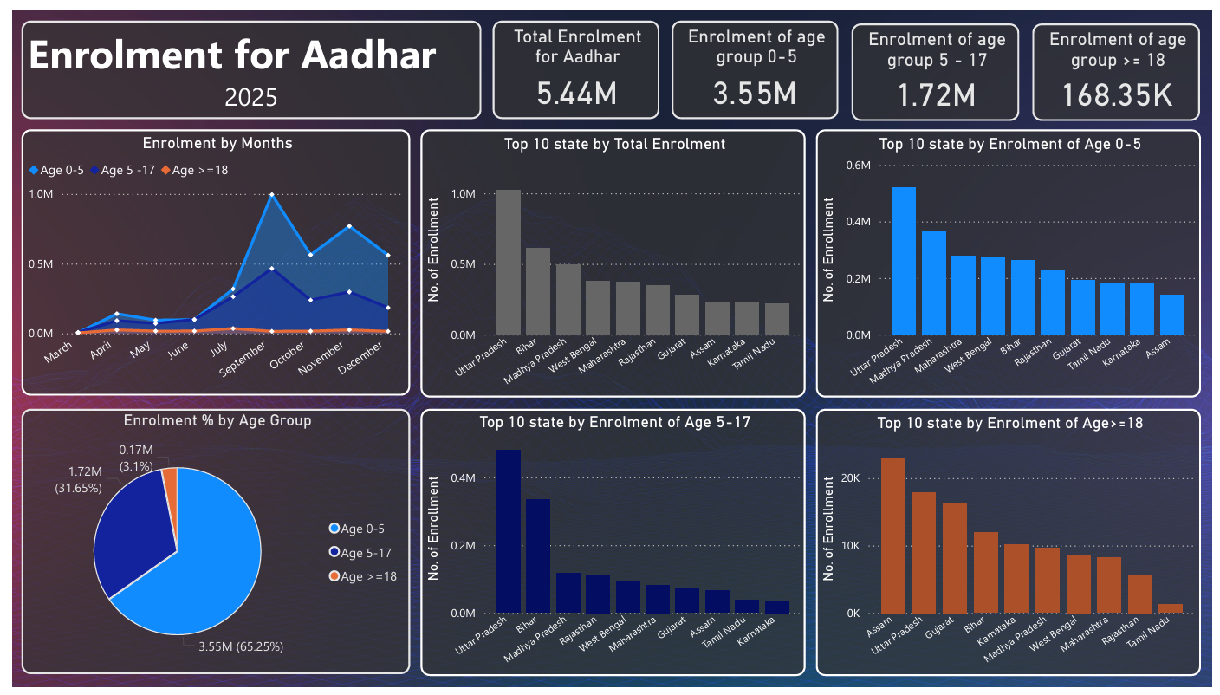
Figure 1: Dashboard
The dashboard shows in Figure 1 indicates a total of 5.44 million Aadhaar enrolments during the observed period. Among these, enrolment is heavily concentrated in younger age groups. Children aged 0–5 years account for 3.55 million enrolments (approximately 65 percent), followed by the 5–17 years age group with 1.72 million enrolments (around 32 percent). Enrolments for individuals aged 18 years and above remain comparatively low at 168.35k (about 3 percent). This highlights the strong emphasis on early age Aadhaar registration and suggests that adult enrolment may be nearing saturation.
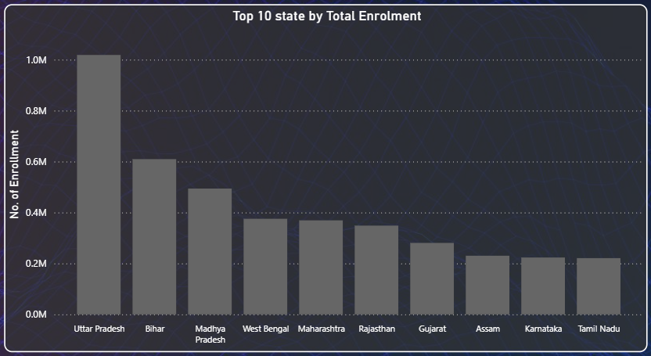
Figure 2: Top 10 State by Total Enrolment
This chart shows in figure 2 presents the top ten states ranked by total Aadhaar enrolments during the study period. Uttar Pradesh emerges as the highest contributor, with enrolments exceeding one million, significantly outperforming all other states. This is followed by Bihar and Madhya Pradesh, indicating a strong concentration of enrolment activity in high-population states. States such as West Bengal, Maharashtra, and Rajasthan form a middle tier with moderate enrolment levels, while Gujarat, Assam, Karnataka, and Tamil Nadu show comparatively lower enrolment figures among the top ten. The sharp decline after the top three states highlights regional disparities in enrolment intensity.
This pattern suggests that Aadhaar enrolment activity is closely linked to population size, demographic structure, and outreach effectiveness. However, it also indicates potential under-enrolment or saturation effects in certain states, where enrolment growth may have slowed. These insights can help authorities prioritize targeted enrolment or update initiatives in lower-performing regions while optimizing resources in high-volume states.
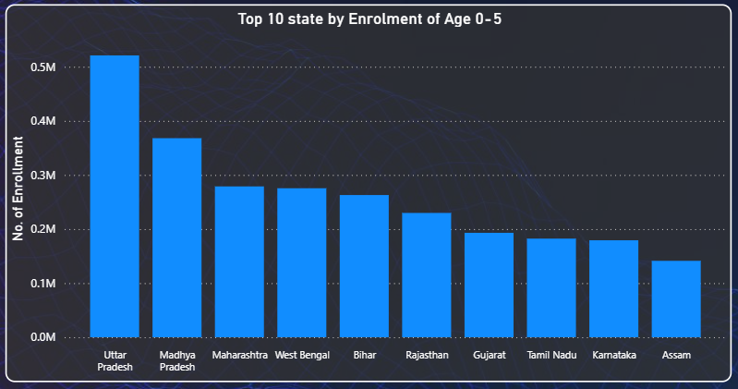
Figure 3: Top 10 state by Enrolment of Age 0-5
This chart shows in figure 3 illustrates the top ten states by Aadhaar enrolment for children aged 0–5 years, representing early childhood registration trends. Uttar Pradesh leads significantly, recording the highest number of child enrolments, followed by Madhya Pradesh. This indicates strong early age Aadhaar adoption in these states, possibly driven by active birth registration linkage, anganwadi outreach, and child welfare programs.
States such as Maharashtra, West Bengal, and Bihar form a middle tier with relatively comparable enrolment levels, reflecting consistent but varied implementation of child focused enrolment initiatives. Rajasthan and Gujarat show moderate enrolment, while Tamil Nadu, Karnataka, and Assam record comparatively lower child enrolment figures among the top ten.
The variation across states highlights differences in early age enrolment awareness, administrative outreach, and integration with healthcare or education systems. Lower enrolment levels in some states may indicate delayed Aadhaar registration for children or gaps in institutional coordination.
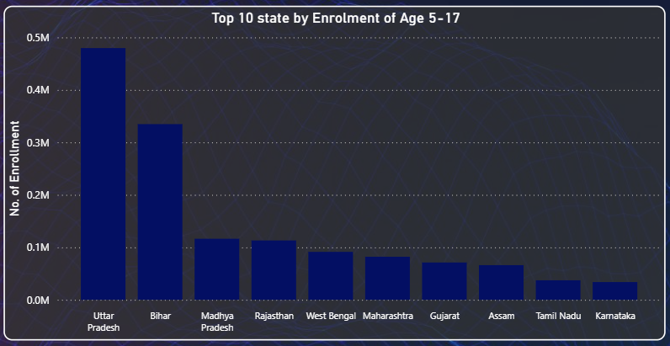
Figure 4: Top 10 State by Enrolment of Age 5-17
This chart shows in figure 4 presents the state wise distribution of Aadhaar enrolments for individuals aged 5–17 years, representing enrolment patterns among school age children and adolescents. Uttar Pradesh records the highest enrolment in this age group, followed by Bihar, together accounting for a substantial share of adolescent Aadhaar registrations. This reflects both high population size and the impact of school linked enrolment initiatives.
Madhya Pradesh and Rajasthan form the next tier, showing moderate enrolment levels, while West Bengal, Maharashtra, and Gujarat display relatively lower but consistent enrolment figures. States such as Assam, Tamil Nadu, and Karnataka contribute the least within the top ten, indicating either higher enrolment saturation or delayed registration trends.
The steep decline after the top two states highlights significant regional variation in adolescent enrolment behavior. Since Aadhaar is often required for school admissions, scholarships, and examinations, uneven enrolment at this stage may impact access to educational and welfare benefits.
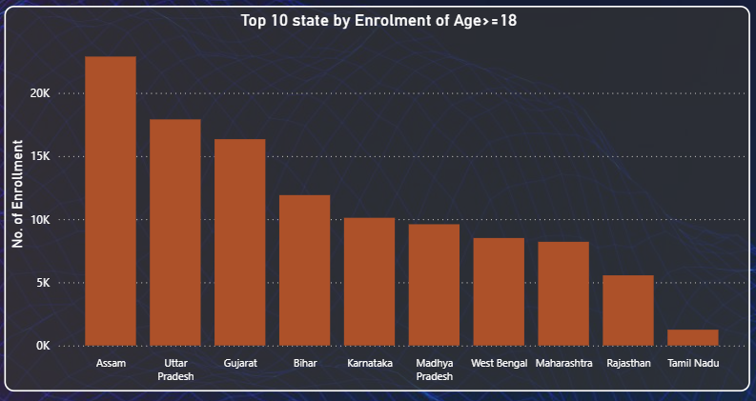
Figure 5: Top 10 state by Enrolment of Age >= 18
This chart shows in figure 5 depicts the top ten states by Aadhaar enrolment for individuals aged 18 years and above, representing adult first time enrolments. Assam records the highest adult enrolment, followed by Uttar Pradesh and Gujarat. Unlike child and adolescent enrolment patterns, adult enrolments are relatively low across all states, indicating that Aadhaar coverage among adults is largely saturated in most regions.
The higher adult enrolment in Assam may suggest delayed enrolment, migration related registrations, or region specific outreach initiatives. States such as Bihar, Karnataka, and Madhya Pradesh show moderate adult enrolment activity, while Maharashtra, Rajasthan, and Tamil Nadu record the lowest adult enrolment figures among the top ten.
The uneven distribution and low overall volume of adult enrolments highlight a shift in Aadhaar system usage from new registrations toward update and correction services. This trend is important for understanding changing service demand patterns.
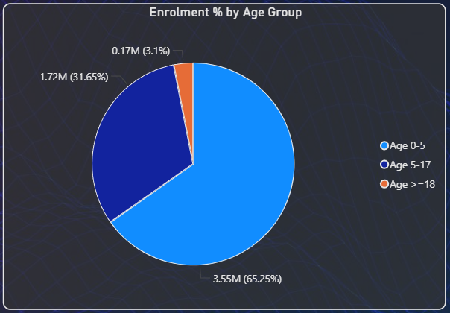
Figure 6: Enrolment % by Age Group
This chart in figure 6 illustrates the proportion of Aadhaar enrolments across different age groups during the study period. The 0–5 years age group accounts for the largest share, with 3.55 million enrolments representing approximately 65.25 percent of the total. This indicates a strong focus on early childhood Aadhaar registration, likely driven by integration with birth registration systems and child welfare programs.
The 5–17 years age group contributes 1.72 million enrolments around 31.65 percent, reflecting consistent enrolment activity among school aged children and adolescents. This trend suggests the influence of school admissions, scholarships, and educational requirements on Aadhaar registration.
In contrast, enrolments for individuals aged 18 years and above constitute only 0.17 million, approximately 3.1 percent of total enrolments. The comparatively low share of adult enrolment indicates that Aadhaar coverage among adults is largely saturated, with fewer first time registrations occurring in this segment.

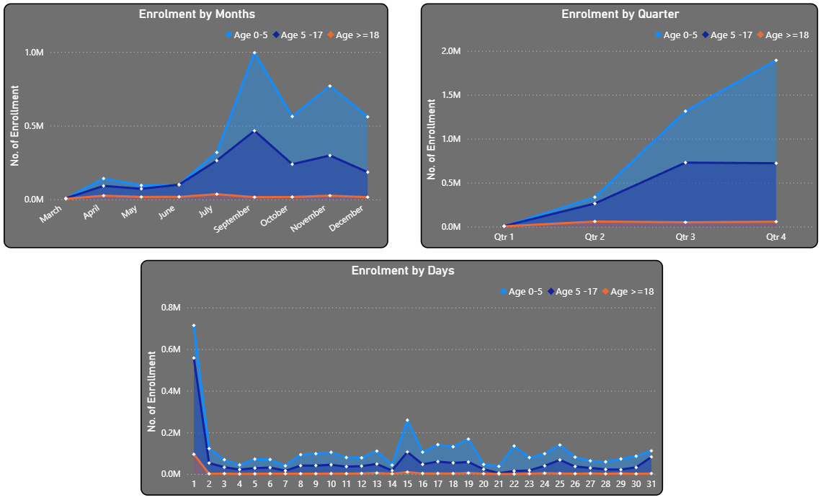
Figure 7: Time series analysis for enrolment
- Enrolment by months
The monthly trend shows a normal increase in enrolment activity from March to July, followed by a sharp peak during September, particularly for the 0–5 years and 5–17 years age groups. This surge suggests the influence of structured enrolment drives, school admission cycles, and child focused government programs. Enrolment levels decline after September but remain relatively elevated during October and November, before tapering off in December. There is not a single entry in the month of August.
Adult enrolment (18 years and above) remains consistently low across all months, showing minimal seasonal variation. This further reinforces the observation that most adult Aadhaar registrations have already been completed, and current demand is largely driven by younger age groups.
- Enrolment by Quarter
Quarterly analysis reveals a clear upward trend in enrolment activity across the year. Quarter 1 and Quarter 2 show relatively lower enrolment volumes, while Quarter 3 and Quarter 4 account for the majority of enrolments, especially in the 0–5 years and 5–17 years categories. The sharp rise in the second half of the year highlights the cumulative effect of enrolment campaigns and institutional schedules. Adult enrolment remains flat across quarters, indicating stable saturation levels and limited new registrations.
- Enrolment by Days of month
Daily enrolment patterns exhibit significant variability, with notably higher enrolments during the early and mid-month periods. On the 1st day of month highest no. of enrolment is done and again its goes higher on the middle of month 15th – 20th day, it mean most of the people go for enrolment on the 1st day and middle days of month. Spikes observed around specific days may correspond to administrative cycles, operational scheduling of enrolment centers, or targeted drive days. In contrast, enrolment activity tends to decline towards the end of the month. Children in the 0–5 years age group consistently dominate daily enrolment volumes, while adult enrolments remain minimal and stable throughout the month.
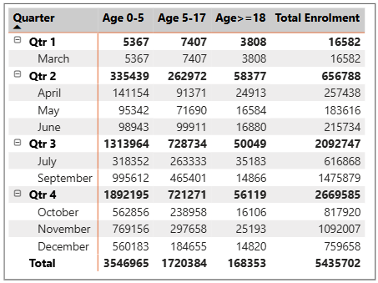
Table 1: Enrolment by Months
The table presents a consolidated view of Aadhaar enrolments segmented by quarter and age group, providing a structured summary of enrolment dynamics throughout the year. The total enrolment across all quarters stands at approximately 5.44 million, with a clear increase in enrolment activity as the year progresses.
Quarter 1 records the lowest enrolment, reflecting the initial phase of the enrolment cycle. A substantial increase is observed in Quarter 2, driven primarily by a rise in enrolments among the 0–5 years and 5–17 years age groups. This upward trend continues into Quarter 3, which shows the highest overall enrolment volume, accounting for a significant proportion of the annual total. Quarter 4 maintains high enrolment levels, though slightly lower than Quarter 3, indicating sustained enrolment activity toward the end of the year.
Across all quarters, the 0–5 years age group consistently contributes the largest share of enrolments, followed by the 5–17 years group. Enrolment for individuals aged 18 years and above remains comparatively low and stable throughout the year, reinforcing the observation that adult Aadhaar enrolment is largely saturated. Monthly breakdown within each quarter further highlights that enrolment peaks align with organized enrolment drives and institutional schedules. The strong concentration of enrolments in the second half of the year suggests the effectiveness of targeted outreach initiatives during this period.
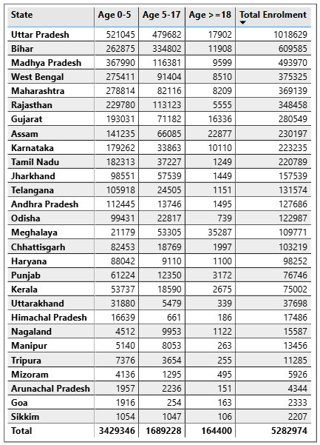
Table 2: State wise Enrolment
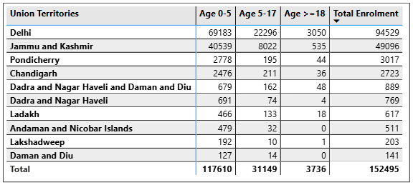
Table 3: Enrolment for Union territories
States:-
Among states, Aadhaar enrolment is heavily concentrated in a few large and populous regions. Uttar Pradesh leads with over one million enrolments, followed by Bihar and Madhya Pradesh. These states show strong enrolment in the 0–5 years and 5–17 years categories, indicating effective early age registration and school linked enrolment initiatives.
Mid-sized states such as West Bengal, Maharashtra, Rajasthan, and Gujarat show moderate but consistent enrolment levels across child and adolescent groups. Assam stands out with a relatively higher proportion of adult enrolment (18 years and above) compared to many other states, suggesting delayed enrolment, migration related registrations, or region specific enrolment drives.
Smaller states and northeastern regions including Sikkim, Mizoram, Tripura, and Arunachal Pradesh record lower absolute enrolment figures, largely due to smaller population sizes and higher saturation levels. Across all states, adult enrolment remains the lowest contributor, reinforcing the maturity of Aadhaar coverage among adults.
Union Territories:-
Union Territories contribute a much smaller share of total enrolments compared to states, reflecting their limited population size. Delhi records the highest enrolment among UTs, driven primarily by strong enrolment in the 0–5 years and 5–17 years age groups. Jammu and Kashmir follows, showing moderate enrolment levels across children and adolescents.
Other UTs such as Puducherry, Chandigarh, and Dadra and Nagar Haveli and Daman and Diu show relatively low but stable enrolment figures. Smaller UTs including Lakshadweep, Ladakh, and Andaman and Nicobar Islands exhibit minimal enrolment volumes, which may indicate high saturation, geographic constraints, or limited enrolment infrastructure.

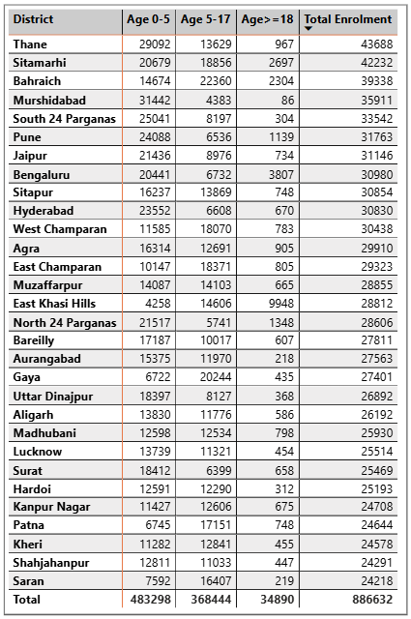
Table 4: Top 30 District by Enrolment
Thane records the highest total enrolment among the listed districts, driven largely by strong enrolment in the 0–5 years category, indicating effective early childhood registration in urban and semi-urban areas. Sitamarhi and Bahraich follow closely, showing balanced enrolment across both child and adolescent age groups.
Districts such as Murshidabad and South 24 Parganas demonstrate significant enrolment in the 0–5 years group but comparatively lower adult enrolment, reflecting the maturity of Aadhaar coverage among adults. Bengaluru stands out with a relatively higher 18+ enrolment, likely due to migration, employment-driven registrations, and urban population inflow. A strong representation of districts from Uttar Pradesh and Bihar is evident, including Sitapur, West Champaran, Muzaffarpur, Gaya, Madhubani, Lucknow, and Patna. These districts show higher enrolment volumes in the 5–17 years age group, suggesting effective school-linked enrolment drives and awareness programs.
Urban and metropolitan districts such as Hyderabad, Pune, Jaipur, and Surat show consistent enrolment patterns but lower overall volumes compared to densely populated rural districts. This suggests that population size plays a more dominant role than urbanization alone.
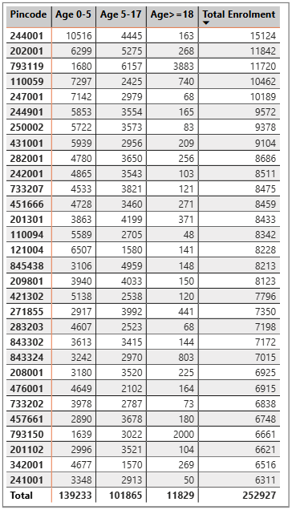
Table 5: Pincode wise Enrolment

PIN code 244001 records the highest total enrolment, driven predominantly by the 0–5 years age group, indicating strong early-age registration coverage. Other high-performing pincodes such as 202001, 793119, and 110059 also show substantial enrolment volumes, reflecting effective outreach and accessibility of enrolment services.
Several pincodes including 793119, 451666, and 793150 display comparatively higher 18+ enrolment, suggesting adult registration driven by migration, employment needs, or recent documentation updates. In contrast, most pincodes show lower adult enrolment, indicating near-saturation of Aadhaar coverage among the adult population.
Across nearly all pincodes:
- Age 0–5 contributes the largest share of total enrolment, emphasizing a focus on early Aadhaar registration
- Age 5–17 enrolment remains consistently strong, likely supported by school-linked enrolment initiatives
- Age ≥18 enrolment forms the smallest share, highlighting maturity in adult Aadhaar coverage

Findings:-
• The overall enrolment distribution is heavily skewed towards the younger population, with the 0–5 age group forming the largest share, followed by the 5–17 age group, while enrolments for individuals aged 18 and above remain minimal, indicating near-saturation of Aadhaar coverage among adults.
• The dominance of child enrolments reflects the successful integration of Aadhaar with birth registration systems, healthcare services, and early childhood welfare programs, suggesting that Aadhaar has transitioned into a lifecycle-based identity system rather than an expansion-driven initiative.
• States with large populations such as Uttar Pradesh, Bihar, Madhya Pradesh, West Bengal, Maharashtra, and Rajasthan consistently record the highest enrolment volumes across all age groups, highlighting the strong relationship between population density and absolute enrolment numbers.
• Lower enrolment figures in several southern and western states indicate early adoption and mature Aadhaar coverage, rather than gaps in accessibility or implementation.
• Union Territories show significantly lower enrolment volumes due to limited population sizes, with Delhi being a notable exception because of high population density and continuous migratory inflows.
• Age-wise state analysis shows that enrolments in the 5–17 age group are strongly influenced by school admissions, scholarships, and education-linked requirements, reinforcing the role of institutional triggers in driving Aadhaar registration.
• Adult enrolments are largely concentrated in urban centers, migration-prone districts, and employment hubs, suggesting that most new adult registrations are driven by relocation, employment verification, or documentation needs rather than first-time enrolment.
• Monthly and quarterly trends indicate clear seasonality, with enrolment volumes peaking during the third and fourth quarters of the year, aligning with academic calendars, government campaigns, and administrative cycles.
• Daily enrolment patterns show higher activity during the early part of the month, followed by stabilization, reflecting operational scheduling, public behavior, and the timing of enrolment drives.
• District-level analysis reveals that urban and semi-urban districts consistently outperform rural districts in total enrolments due to better infrastructure, higher population density, and greater access to enrolment centers.
• Rural districts display a higher proportion of child enrolments, emphasizing the importance of localized health centers, schools, and community-level outreach in enabling Aadhaar adoption.
• Pincode-level analysis uncovers micro-level disparities within districts, where neighbouring pincodes exhibit significantly different enrolment volumes, highlighting the influence of service accessibility and awareness at the local level.
• The consistently low contribution of the 18+ age group across states, districts, and pincodes indicates that future Aadhaar efforts should prioritize update and correction services over large-scale adult enrolment drives.
• Seasonal spikes in enrolment suggest that enrolment infrastructure and staffing should be dynamically scaled during peak periods to avoid service bottlenecks and improve user experience.
• Strengthening Aadhaar linkage with birth registration, immunization programs, and school enrollment systems can further improve early-age coverage and data accuracy.
• Urban areas and migration corridors would benefit from enhanced Aadhaar update facilities, particularly for biometric refresh and demographic corrections.
• Data-driven targeting at district and pincode levels can enable more efficient allocation of enrolment resources, mobile units, and outreach initiatives.
Conclusion:-
The analysis of Aadhaar enrolment data across age groups, time periods, and geographic levels indicates that Aadhaar has reached a mature stage of nationwide adoption. Enrolment activity is now primarily driven by early-life registration and institutional requirements rather than first-time adult enrolment. The dominance of the 0–5 and 5–17 age groups reflects strong integration of Aadhaar with birth registration, education, and welfare delivery systems, while the consistently low enrolment among adults suggests near-universal coverage in that segment.
Geographic patterns show that high-population states, urban districts, and migration-prone areas continue to contribute the highest enrolment volumes, whereas smaller states and Union Territories exhibit stable and saturated enrolment trends. Temporal analysis reveals seasonal peaks aligned with academic cycles and administrative campaigns, highlighting the importance of adaptive operational planning. Micro-level variations at district and pincode levels further emphasize the role of local accessibility and awareness in shaping enrolment outcomes.

